|  |  |
| --- | --- |
| **EXP NO: 1** | **SETTING UP THE ENVIRONMENT AND PREPROCESSING THE DATA** |

# AIM:

To set up a fully functional machine learning development environment and to perform

data preprocessing operations like handling missing values, encoding categorical variables, feature scaling, and splitting datasets**.**

# ALGORITHM:

1. Install Required Libraries:
   * Install numpy, pandas, matplotlib, seaborn, and scikit-learn using pip.
2. Import Libraries.
3. Load Dataset:
   * Load any dataset (e.g., Titanic or Iris) using pandas.
4. Data Exploration:
   * Use df.info(), df.describe(), df.isnull().sum() to understand the data.
5. Handle Missing Values:
   * Use .fillna() or .dropna() depending on the strategy.
6. Encode Categorical Data:
   * Use pd.get_dummies() or LabelEncoder.
7. Feature Scaling:
   * Normalize or standardize the numerical features using StandardScaler or MinMaxScaler.
8. Split Dataset:
   * Use train_test_split() from sklearn to create training and testing sets.
9. Display the Preprocessed Data.

# CODE:

# 1. Install necessary libraries (if not already installed)

# !pip install numpy pandas matplotlib seaborn scikit-learn

# 2. Import libraries import pandas as pd import numpy as np

from sklearn.model_selection import train_test_split

from sklearn.preprocessing import StandardScaler, LabelEncoder import seaborn as sns

import matplotlib.pyplot as plt

# 3. Load dataset

df = sns.load_dataset(‘titanic’) # Titanic dataset df.head()

# 4. Explore the dataset print(df.info()) print(df.describe()) print(df.isnull().sum())

# 5. Handle missing values

# Fill age with median, embark_town with mode df[‘age’].fillna(df[‘age’].median(), inplace=True) df[‘embark_town’].fillna(df[‘embark_town’].mode()[0], inplace=True) df.drop(columns=[‘deck’], inplace=True) # too many missing values

# 6. Encode categorical variables

# Convert ‘sex’ and ‘embark_town’ using LabelEncoder

le = LabelEncoder()

df[‘sex’] = le.fit_transform(df[‘sex’])

df[‘embark_town’] = le.fit_transform(df[‘embark_town’])

# Drop non-informative or redundant columns

df.drop(columns=[‘embarked’, ‘class’, ‘who’, ‘alive’, ‘adult_male’, ‘alone’], inplace=True)

# 7. Feature Scaling scaler = StandardScaler()

numerical_cols = [‘age’, ‘fare’]

df[numerical_cols] = scaler.fit_transform(df[numerical_cols])

# 8. Split dataset

# Define features (X) and label (y)

X = df.drop(‘survived’, axis=1) y = df[‘survived’]

X_train, X_test, y_train, y_test = train_test_split(X, y, test_size=0.2, random_state=42)

# 9. Show final preprocessed data print(“Training Data Shape:”, X_train.shape) print(“Test Data Shape:”, X_test.shape) X_train.head()

# OUTPUT:

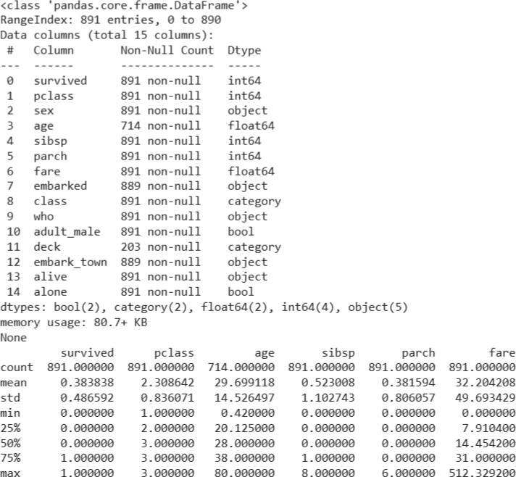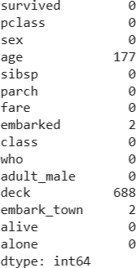

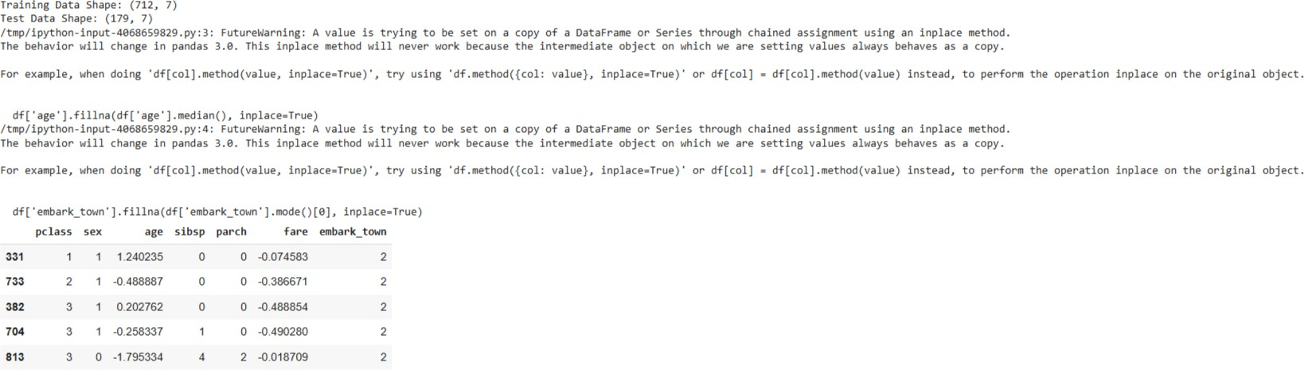

**RESULT:**

The Python environment was successfully set up and the dataset was pre-processed by handling missing values, encoding categorical data, performing feature scaling, and splitting the data into training and testing sets. The dataset is now ready for model training and analysis.